SUPPLEMENTARY MATERIAL

| Table S1. Thin layers of phytoplankton detected at each station and cell density (cel L-1) of the phytoplankton groups present in these samples. ND: no detected; st: station; yy; year; mm: month; dd: day; NaN: no data; REDE: <40 cel L-1. | | | | | | | | | | |
| --- | --- | --- | --- | --- | --- | --- | --- | --- | --- | --- |
| **st** | **yy** | **mm** | **dd** | ***D. acuminata*** | ***D. acuta*** | ***D. caudata*** | ***D. spp*** | ***Pseudo-nitzschia spp.*** | ***Alexandrium spp.*** | ***G. catenatum*** | |
| **A0** | 2012 | 6 | 25 | 120 | 0 | 0 | 0 | 13365 | NaN | 0 | |
| **A1** | 2013 | 3 | 19 | 80 | 0 | 0 | 0 | 0 | 0 | 0 | |
| **A1** | 2015 | 6 | 22 | 160 | 0 | 0 | 0 | 46035 | 0 | 0 | |
| **A2** | 2012 | 3 | 27 | 40 | 0 | 0 | 0 | 0 | NaN | 0 | |
| **A2** | 2013 | 8 | 13 | 320 | 0 | 0 | 0 | 323730 | 0 | 0 | |
| **A2** | 2014 | 3 | 10 | 0 | 0 | 0 | 0 | 0 | 0 | 0 | |
| **A2** | 2014 | 6 | 3 | 160 | 0 | 0 | 0 | 102465 | 0 | 0 | |
| **A2** | 2014 | 10 | 28 | 40 | 0 | 0 | 0 | 11880 | 0 | 0 | |
| **A2** | 2015 | 7 | 13 | 240 | 0 | 0 | 0 | 75735 | 0 | 0 | |
| **A2** | 2015 | 8 | 10 | 0 | 0 | 0 | 0 | 10395 | 0 | 0 | |
| **A2** | 2015 | 9 | 7 | 0 | 0 | 0 | 0 | 12265 | 0 | 0 | |
| **A3** | 2013 | 6 | 18 | 160 | 0 | 0 | 0 | 0 | 0 | 0 | |
| **A3** | 2015 | 5 | 5 | 40 | 0 | 0 | 0 | 7425 | 0 | 0 | |
| **A4** | 2012 | 4 | 2 | 40 | 0 | 0 | 0 | 31185 | NaN | 0 | |
| **A4** | 2012 | 8 | 27 | 120 | 0 | 0 | 0 | REDE | 0 | 0 | |
| **A4** | 2013 | 4 | 22 | 600 | 0 | 0 | 0 | 0 | 0 | 0 | |
| **A4** | 2015 | 7 | 27 | 120 | 0 | 0 | 0 | 20790 | 0 | 0 | |
| **A6** | 2012 | 6 | 25 | 0 | 0 | 0 | 0 | REDE | NaN | 0 | |
| **A6** | 2013 | 9 | 9 | 0 | 0 | 0 | 0 | 34155 | 0 | 0 | |
| **A8** | 2012 | 5 | 14 | 120 | 0 | 0 | 0 | 71280 | NaN | 0 | |
| **A8** | 2012 | 6 | 25 | 120 | 0 | 0 | 0 | 22275 | NaN | 0 | |
| **A8** | 2014 | 5 | 12 | 680 | 0 | 0 | 0 | REDE | 0 | 0 | |
| **A8** | 2015 | 6 | 29 | 40 | 0 | 0 | 0 | 19305 | 0 | 0 | |
| **A9** | 2015 | 7 | 28 | 40 | 0 | 0 | 0 | 10395 | 0 | 0 | |
| **M1** | 2014 | 4 | 15 | 0 | 0 | 0 | 0 | 0 | 0 | 0 | |
| **M1** | 2015 | 7 | 14 | 280 | 0 | 0 | 0 | 1340955 | 0 | 0 | |
| **M1** | 2015 | 8 | 4 | 160 | 0 | 0 | 40 | 57915 | 0 | 0 | |
| **M2** | 2013 | 9 | 10 | 0 | 0 | 0 | 0 | 686070 | 0 | 0 | |
| **M3** | 2012 | 7 | 17 | 0 | 0 | 0 | 0 | 31185 | NaN | 0 | |
| **M4** | 2012 | 5 | 22 | 200 | 0 | 0 | 0 | 50490 | NaN | 0 | |
| **M4** | 2013 | 6 | 19 | 720 | 0 | 0 | 0 | 2970 | 0 | 0 | |
| **M4** | 2015 | 3 | 10 | 40 | 0 | 0 | 0 | 8910 | 0 | 0 | |
| **M4** | 2015 | 7 | 28 | 40 | 0 | 0 | 0 | 4455 | 0 | 0 | |
| **M5** | 2012 | 8 | 28 | 80 | 0 | 0 | 40 | 2970 | 0 | 0 | |
| **M5** | 2013 | 5 | 21 | 160 | 0 | 0 | 0 | 0 | 0 | 0 | |
| **M8** | 2015 | 8 | 4 | 0 | 0 | 0 | 40 | 0 | 0 | 0 | |
| **P1** | 2012 | 7 | 16 | 0 | 0 | 0 | 0 | 25245 | 0 | 0 | |
| **P1** | 2013 | 5 | 13 | 680 | 0 | 0 | 0 | 5940 | 0 | 0 | |
| **P1** | 2015 | 8 | 3 | 160 | 0 | 0 | 0 | 2970 | 0 | 0 | |
| **P2** | 2012 | 5 | 14 | 0 | 0 | 0 | 0 | 17820 | NaN | 0 | |
| **P2** | 2012 | 6 | 25 | 200 | 0 | 0 | 0 | 348975 | NaN | 0 | |
| **P2** | 2012 | 7 | 16 | 0 | 0 | 0 | 0 | 25245 | 0 | 0 | |
| **P2** | 2012 | 7 | 23 | 40 | 0 | 0 | 0 | 50490 | NaN | 0 | |
| **P2** | 2013 | 5 | 13 | 240 | 0 | 0 | 0 | 29700 | 0 | 0 | |
| **P2** | 2013 | 8 | 12 | 80 | 0 | 0 | 0 | 350460 | 0 | 0 | |
| **P2** | 2014 | 5 | 26 | 2440 | 0 | 0 | 0 | 46035 | 0 | 0 | |
| **P2** | 2014 | 7 | 28 | 120 | 0 | 0 | 0 | 10395 | 0 | 0 | |
| **P2** | 2015 | 6 | 29 | 520 | 0 | 0 | 0 | 62370 | 0 | 0 | |
| **P2** | 2015 | 8 | 3 | 80 | 0 | 0 | 0 | 0 | 0 | 0 | |
| **P3** | 2012 | 5 | 14 | 200 | 0 | 0 | 0 | 4455 | NaN | 0 | |
| **P3** | 2012 | 6 | 25 | 40 | 0 | 0 | 0 | 392040 | NaN | 0 | |
| **P3** | 2012 | 7 | 30 | 0 | 0 | 0 | 40 | 8910 | REDE | 0 | |
| **P3** | 2013 | 7 | 1 | 0 | 0 | 0 | 0 | 17820 | 0 | 0 | |
| **P3** | 2015 | 7 | 27 | 0 | 0 | 0 | 0 | 2970 | 0 | 0 | |

|  |  |  |  |  |  |  |  |  |  |  |
| --- | --- | --- | --- | --- | --- | --- | --- | --- | --- | --- |
| st | yy | mm | dd | *D. acuminata* | *D. acuta* | *D. caudata* | *D.* spp | *Pseudo-nitzschia* spp. | *Alexandrium* spp. | *G. catenatum* |
| P4 | 2012 | 5 | 14 | 560 | 0 | 0 | 0 | 14850 | NaN | 0 |
| P4 | 2012 | 6 | 4 | 1760 | 0 | 0 | 80 | 26730 | 0 | 0 |
| P4 | 2012 | 6 | 25 | 360 | 0 | 0 | 0 | 173745 | NaN | 0 |
| P4 | 2012 | 7 | 16 | 40 | 0 | 0 | 160 | 49005 | 0 | 0 |
| P4 | 2012 | 9 | 3 | 40 | 0 | 0 | 0 | 1362743 | 0 | 0 |
| P4 | 2012 | 9 | 10 | NaN | NaN | NaN | NaN | NaN | NaN | NaN |
| P4 | 2013 | 5 | 13 | 480 | 0 | 0 | 40 | 10395 | 0 | 0 |
| P4 | 2013 | 7 | 22 | 10040 | 0 | 80 | 120 | 2970 | 0 | 0 |
| P4 | 2014 | 3 | 10 | 0 | 0 | 0 | 0 | 0 | 0 | 0 |
| P4 | 2015 | 7 | 27 | 120 | 40 | 0 | 0 | 0 | 0 | 0 |
| P4 | 2015 | 8 | 3 | 520 | 0 | 0 | 0 | 0 | 0 | 0 |
| P5 | 2012 | 5 | 28 | 1320 | 0 | 0 | 0 | 16335 | 0 | 0 |
| P5 | 2012 | 6 | 25 | 440 | 0 | 0 | 0 | 368280 | NaN | 0 |
| P5 | 2013 | 5 | 6 | 160 | 0 | 0 | 0 | 10395 | 0 | 0 |
| P5 | 2013 | 8 | 12 | 0 | 0 | 0 | 0 | 289575 | 0 | 0 |
| P5 | 2015 | 6 | 1 | 160 | 0 | 0 | 0 | 20790 | 0 | 0 |
| P5 | 2015 | 7 | 20 | 640 | 0 | 0 | 120 | 66825 | 0 | 0 |
| P5 | 2015 | 7 | 27 | 120 | 0 | 0 | 0 | 4455 | 0 | 0 |
| P5 | 2015 | 8 | 3 | 80 | 0 | 0 | 0 | 44555 | 0 | 0 |
| P6 | 2012 | 5 | 14 | 240 | 0 | 0 | 0 | 4455 | NaN | 0 |
| P6 | 2012 | 6 | 25 | 80 | 0 | 0 | 0 | 821624 | NaN | 0 |
| P6 | 2013 | 5 | 6 | 120 | 0 | 0 | 0 | 5940 | 0 | 0 |
| P6 | 2013 | 9 | 16 | 0 | 0 | 0 | 0 | 17820 | 0 | 0 |
| P6 | 2014 | 5 | 26 | 1680 | 0 | 0 | 0 | 23760 | 0 | 0 |
| P6 | 2015 | 7 | 27 | 40 | 40 | 0 | 0 | 2970 | 0 | 0 |
| P7 | 2015 | 3 | 9 | 40 | 0 | 0 | 0 | 7425 | 0 | 0 |
| P8 | 2012 | 5 | 14 | 560 | 0 | 0 | 0 | 11880 | NaN | 0 |
| P8 | 2012 | 7 | 16 | 120 | 0 | 0 | 0 | 38610 | REDE | 0 |
| P9 | 2012 | 7 | 30 | 40 | 0 | 0 | 0 | 13365 | 0 | 120 |
| P9 | 2013 | 5 | 13 | 240 | 0 | 0 | 0 | 11880 | 0 | 0 |
| P9 | 2014 | 3 | 5 | 0 | 0 | 0 | 0 | 0 | 0 | 0 |
| P9 | 2015 | 7 | 27 | 40 | 0 | 0 | 0 | 0 | 0 | 0 |
| PA | 2012 | 5 | 21 | 0 | 0 | 0 | 0 | 1485 | 0 | 0 |
| PA | 2015 | 7 | 27 | 0 | 0 | 0 | 0 | 7425 | 0 | 0 |
| B1 | 2012 | 5 | 14 | 0 | 0 | 0 | 0 | 14850 | NaN | 0 |
| V1 | 2012 | 5 | 14 | 80 | 0 | 0 | 0 | 29700 | NaN | 0 |
| V1 | 2014 | 5 | 5 | 1800 | 0 | 0 | 160 | 13365 | 0 | 0 |
| V1 | 2015 | 7 | 27 | 440 | 0 | 0 | 0 | 2970 | 0 | 0 |
| V2 | 2012 | 5 | 14 | 40 | 0 | 0 | 40 | 11880 | NaN | 0 |
| V2 | 2012 | 5 | 21 | 0 | 0 | 0 | 0 | 69795 | 0 | 0 |
| V2 | 2014 | 5 | 5 | 2680 | 0 | 0 | 0 | REDE | 0 | 0 |
| V3 | 2014 | 5 | 5 | 200 | 0 | 0 | 0 | 0 | 0 | 0 |
| V5 | 2012 | 6 | 4 | 1080 | 0 | 0 | 0 | 35640 | 0 | 0 |
| V5 | 2012 | 8 | 27 | 240 | 0 | 0 | 40 | 167805 | 0 | 0 |
| V5 | 2013 | 5 | 20 | 80 | 0 | 0 | 0 | 20790 | 0 | 0 |
| V5 | 2013 | 7 | 29 | 120 | 0 | 0 | 40 | 141075 | 0 | 0 |
| V6 | 2012 | 5 | 14 | 480 | 0 | 0 | 0 | 20790 | NaN | 0 |
| V6 | 2012 | 6 | 25 | 440 | 0 | 0 | 0 | 90585 | NaN | 0 |
| V6 | 2012 | 8 | 27 | 80 | 0 | 0 | 40 | 289575 | 0 | 0 |
| V6 | 2013 | 8 | 12 | 240 | 0 | 0 | 40 | 375705 | 0 | 0 |
| V6 | 2014 | 5 | 12 | 3960 | 0 | 0 | 0 | 0 | 0 | 0 |
| V6 | 2015 | 5 | 18 | 2680 | 80 | 0 | 80 | 22275 | 0 | 0 |
| V7 | 2012 | 5 | 14 | 320 | 0 | 0 | 0 | 19305 | NaN | 0 |
| V7 | 2012 | 5 | 21 | 120 | 0 | 0 | 0 | 74250 | 0 | 0 |
| V7 | 2013 | 8 | 12 | 40 | 0 | 0 | 0 | 341550 | 0 | 0 |

| Table S2. Annual mean cell density (cel·L-1) of *Dinophysis acuminata* and *Pseudo-nitzschia* spp. computed for each station and their 95% confidence intervals (CI). | | | | | | | | |
| --- | --- | --- | --- | --- | --- | --- | --- | --- |
|  |  | ***D. acuminata*** | | |  | ***Pseudo-nitzschia* spp** | | |
| **Estación** |  | **Mean** |  | **CI** |  | **Mean** |  | **CI** |
| **V1** |  | 443 |  | [257, 671] |  | 41895 |  | [18246, 64560] |
| **V2** |  | 258 |  | [84, 454] |  | 30446 |  | [14062, 55203] |
| **V3** |  | 41 |  | [26, 79] |  | 16122 |  | [7477, 33038] |
| **V4** |  | 138 |  | [69, 317] |  | 20749 |  | [10501, 35720] |
| **V5** |  | 370 |  | [212, 735] |  | 45375 |  | [22005, 72659] |
| **V6** |  | 394 |  | [233, 598] |  | 42731 |  | [21178, 74330] |
| **V7** |  | 430 |  | [245, 629] |  | 41629 |  | [19983, 72735] |
| **B1** |  | 253 |  | [139, 417] |  | 45949 |  | [23201, 91454] |
| **P1** |  | 358 |  | [205, 587] |  | 37778 |  | [18314, 70727] |
| **P2** |  | 762 |  | [260, 1260] |  | 34049 |  | [19785, 55092] |
| **P3** |  | 644 |  | [283, 1461] |  | 36677 |  | [20441, 56071] |
| **P4** |  | 513 |  | [265, 898] |  | 39499 |  | [18718, 66151] |
| **P5** |  | 854 |  | [424, 1686] |  | 39446 |  | [19061, 57628] |
| **P6** |  | 588 |  | [228, 1266] |  | 36963 |  | [22246, 63059] |
| **P7** |  | 274 |  | [162, 443] |  | 31512 |  | [16682, 50499] |
| **P8** |  | 516 |  | [290, 902] |  | 40745 |  | [23295, 62815] |
| **P9** |  | 707 |  | [339, 1393] |  | 41689 |  | [2385, 67362] |
| **PA** |  | 358 |  | [217, 559] |  | 40505 |  | [18144, 80534] |
| **A0** |  | 394 |  | [206, 688] |  | 125990 |  | [23273, 404090] |
| **A1** |  | 77 |  | [41 154] |  | 46738 |  | [16659, 98950] |
| **A2** |  | 71 |  | [37 130] |  | 29827 |  | [12610, 57148] |
| **A3** |  | 43 |  | [23, 68] |  | 26665 |  | [10611, 64962] |
| **A4** |  | 156 |  | [91, 288] |  | 32329 |  | [12917, 62060] |
| **A5** |  | 28 |  | [16, 48] |  | 19538 |  | [9000, 39909] |
| **A6** |  | 49 |  | [26, 83] |  | 26298 |  | [11056, 58251] |
| **A7** |  | 120 |  | [65, 273] |  | 15401 |  | [8245, 31195] |
| **A8** |  | 291 |  | [136, 421] |  | 25003 |  | [11908, 42107] |
| **A9** |  | 195 |  | [104, 334] |  | 64016 |  | [27642, 168740] |
| **M1** |  | 257 |  | [164, 396] |  | 75020 |  | [43244, 128230] |
| **M2** |  | 525 |  | [226, 1274] |  | 65525 |  | [39495, 137950] |
| **M3** |  | 416 |  | [181, 1204] |  | 51819 |  | [27975, 103330] |
| **M4** |  | 445 |  | [249, 889] |  | 73256 |  | [38009, 127770] |
| **M5** |  | 478 |  | [231, 807] |  | 56279 |  | [25340, 138690] |
| **M6** |  | 422 |  | [193, 946] |  | 87780 |  | [40867, 167560] |
| **M7** |  | 339 |  | [135, 1072] |  | 33551 |  | [17031, 59292] |
| **M8** |  | 438 |  | [235, 752] |  | 39705 |  | [18775, 77259] |

| Table S3. Number of thin layers of phytoplankton (TLP) detected and number of TLP associated with presence, values above median and third quartile, and outliers of *D. acuminata* and *Pseudo-nitzschia* spp. for each station of the monitoring program. The numbers on the bottom are total number (nº) and total percentage (%) of thin layers detected. | | | | | | | | | | | | | | |
| --- | --- | --- | --- | --- | --- | --- | --- | --- | --- | --- | --- | --- | --- | --- |
|  |  | |  | **Presence** | |  | **Above median** | |  | **Above Q3** | |  | **Outliers** | |
|  | **TLP** | |  | ***D.***  ***acuminata*** | ***Pseudo-***  ***nitzschia*** |  | ***D.***  ***acuminata*** | ***Pseudo-***  ***nitzschia*** |  | ***D.***  ***acuminata*** | ***Pseudo-***  ***nitzschia*** |  | ***D.***  ***acuminata*** | ***Pseudo-***  ***nitzschia*** |
| **P0** | | 0 |  | 0 | 0 |  | 0 | 0 |  | 0 | 0 |  | 0 | 0 |
| **P1** | | 3 |  | 2 | 3 |  | 2 | 0 |  | 1 | 0 |  | 0 | 0 |
| **P2** | | 10 |  | 8 | 9 |  | 4 | 6 |  | 1 | 3 |  | 1 | 2 |
| **P3** | | 5 |  | 2 | 5 |  | 1 | 1 |  | 0 | 1 |  | 0 | 1 |
| **P4** | | 11 |  | 9 | 7 |  | 6 | 3 |  | 2 | 2 |  | 2 | 2 |
| **P5** | | 8 |  | 7 | 8 |  | 3 | 5 |  | 2 | 2 |  | 1 | 2 |
| **P6** | | 6 |  | 5 | 6 |  | 3 | 3 |  | 1 | 1 |  | 1 | 1 |
| **P7** | | 1 |  | 1 | 1 |  | 0 | 0 |  | 0 | 0 |  | 0 | 0 |
| **P8** | | 2 |  | 2 | 2 |  | 2 | 0 |  | 0 | 0 |  | 0 | 0 |
| **P9** | | 4 |  | 3 | 2 |  | 1 | 0 |  | 0 | 0 |  | 0 | 0 |
| **PA** | | 2 |  | 0 | 2 |  | 0 | 0 |  | 0 | 0 |  | 0 | 0 |
| **V1** | | 3 |  | 3 | 3 |  | 2 | 2 |  | 2 | 0 |  | 0 | 0 |
| **V2** | | 3 |  | 2 | 2 |  | 1 | 2 |  | 1 | 1 |  | 1 | 1 |
| **V3** | | 1 |  | 1 | 0 |  | 1 | 0 |  | 1 | 0 |  | 0 | 0 |
| **V4** | | 0 |  | 0 | 0 |  | 0 | 0 |  | 0 | 0 |  | 0 | 0 |
| **V5** | | 4 |  | 4 | 4 |  | 3 | 3 |  | 1 | 2 |  | 0 | 0 |
| **V6** | | 6 |  | 6 | 5 |  | 4 | 4 |  | 1 | 2 |  | 1 | 2 |
| **V7** | | 3 |  | 3 | 3 |  | 0 | 3 |  | 0 | 2 |  | 0 | 1 |
| **B1** | | 1 |  | 0 | 1 |  | 0 | 1 |  | 0 | 0 |  | 0 | 0 |
| **A0** | | 1 |  | 1 | 1 |  | 0 | 0 |  | 0 | 0 |  | 0 | 0 |
| **A1** | | 2 |  | 2 | 1 |  | 2 | 1 |  | 2 | 0 |  | 1 | 0 |
| **A2** | | 8 |  | 5 | 6 |  | 5 | 4 |  | 4 | 3 |  | 3 | 1 |
| **A3** | | 2 |  | 2 | 1 |  | 2 | 0 |  | 2 | 0 |  | 0 | 0 |
| **A4** | | 4 |  | 4 | 2 |  | 3 | 1 |  | 3 | 1 |  | 0 | 1 |
| **A5** | | 0 |  | 0 | 0 |  | 0 | 0 |  | 0 | 0 |  | 0 | 0 |
| **A6** | | 2 |  | 0 | 1 |  | 0 | 1 |  | 0 | 1 |  | 0 | 0 |
| **A7** | | 0 |  | 0 | 0 |  | 0 | 0 |  | 0 | 0 |  | 0 | 0 |
| **A8** | | 4 |  | 4 | 3 |  | 2 | 3 |  | 1 | 1 |  | 0 | 1 |
| **A9** | | 1 |  | 1 | 1 |  | 1 | 0 |  | 0 | 0 |  | 0 | 0 |
| **M1** | | 3 |  | 2 | 2 |  | 2 | 2 |  | 1 | 1 |  | 1 | 1 |
| **M2** | | 1 |  | 0 | 1 |  | 0 | 1 |  | 0 | 1 |  | 0 | 1 |
| **M3** | | 1 |  | 0 | 1 |  | 0 | 0 |  | 0 | 0 |  | 0 | 0 |
| **M4** | | 4 |  | 4 | 4 |  | 1 | 2 |  | 1 | 1 |  | 0 | 0 |
| **M5** | | 2 |  | 2 | 1 |  | 0 | 0 |  | 0 | 0 |  | 0 | 0 |
| **M6** | | 0 |  | 0 | 0 |  | 0 | 0 |  | 0 | 0 |  | 0 | 0 |
| **M7** | | 0 |  | 0 | 0 |  | 0 | 0 |  | 0 | 0 |  | 0 | 0 |
| **M8** | | 1 |  | 0 | 0 |  | 0 | 0 |  | 0 | 0 |  | 0 | 0 |
| **TOTAL**  **(nº)** | | 109 |  | 85 | 88 |  | 51 | 48 |  | 27 | 25 |  | 12 | 17 |
| **TOTAL**  **(%)** | | **100** |  | **78** | **81** |  | **47** | **44** |  | **25** | **23** |  | **11** | **16** |

*Figure S1.* Box-and-whiskers plots of monthly *Pseudo-nitzschia* spp. cell density computed for the period 2012-2017. Only those stations where thin phytoplankton layers were detected are included. On each box, the central mark indicates the median, and the bottom and top edges of the box indicate the 1st and 3rd quartiles, respectively. The whiskers extend to the most extreme data points not considered outliers, and the outliers are plotted individually using the ‘+’ symbol. Green lines indicate the monthly mean density and the green dots the density for those sampling when thin layers of phytoplankton were detected.

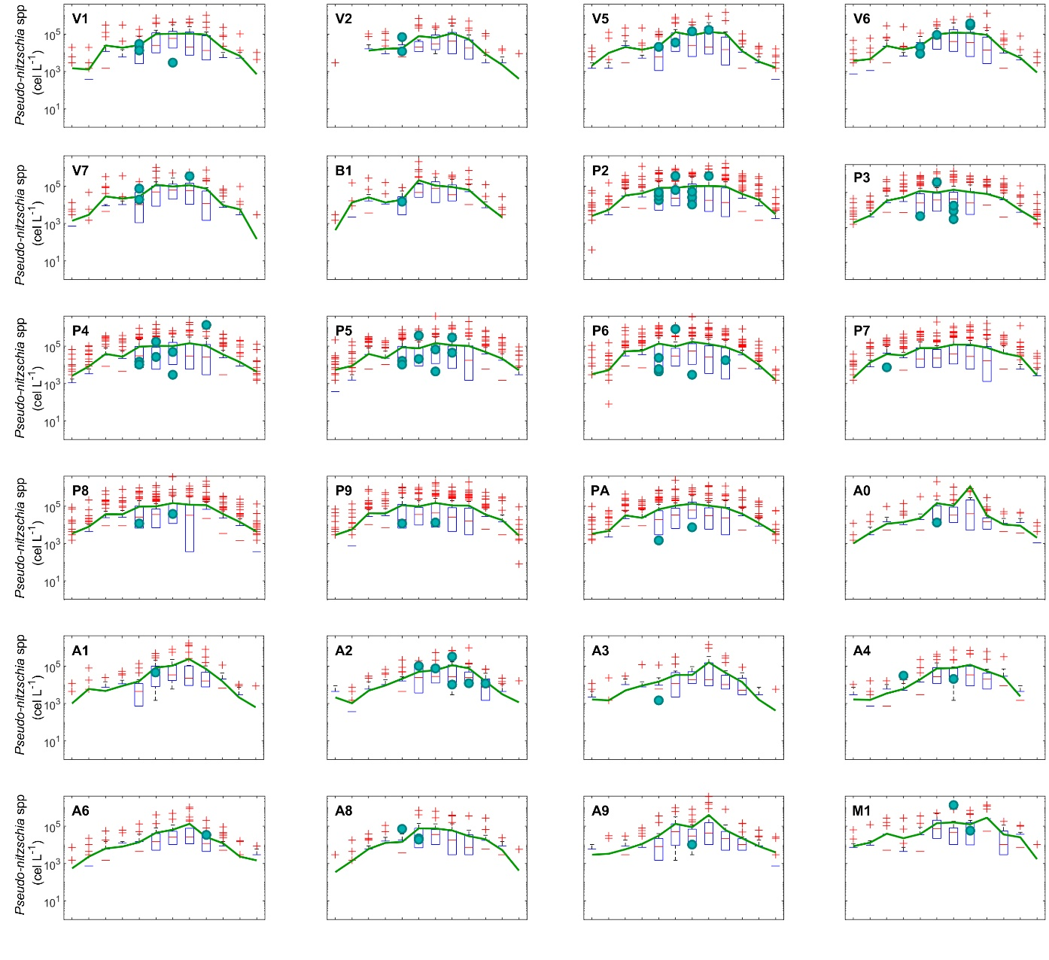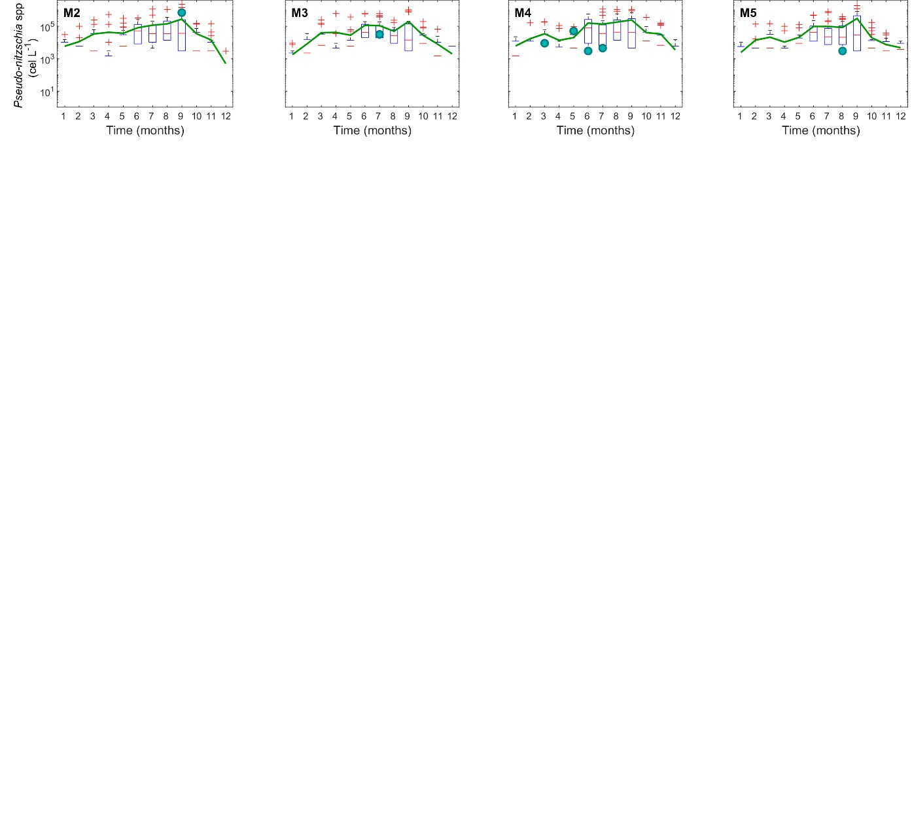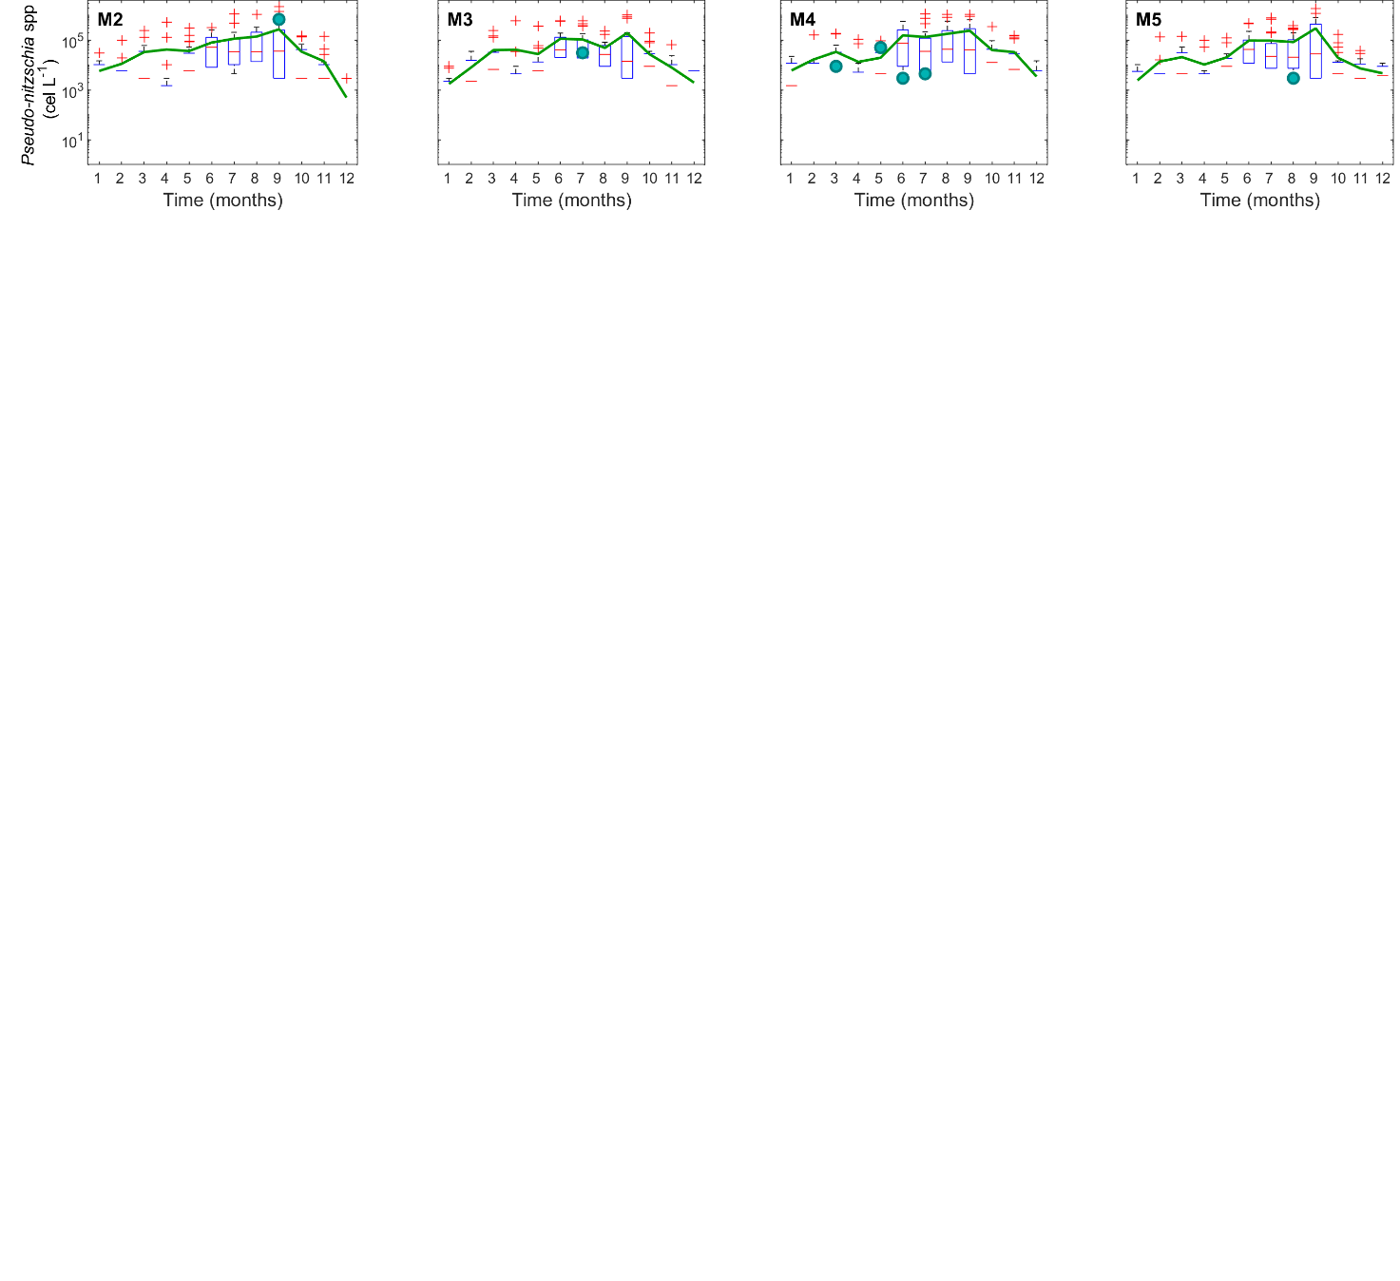

*Figure S2.* Box-and-whiskers plots of monthly *Dinophysis acuminata* cell density computed for the period 2012-2017. Only those stations where thin phytoplankton layers were detected are included. On each box, the central mark indicates the median, and the bottom and top edges of the box indicate the 1st and 3rd quartiles, respectively. The whiskers extend to the most extreme data points not considered outliers, and the outliers are plotted individually using the ‘+’ symbol. Green lines indicate the monthly mean density and the green dots the density for those sampling when thin layers of phytoplankton were detected.

